**APPLICATION OF AN IMPROVED ADAPTIVE BEAMFORMING ALGORITHM FOR 5G IN PDSCH CHANNEL**

**CHAPTER -1**

**ABSTRACT**

Multiple wireless systems coexisting in a 5G network might produce interference in the same frequency band, degrading the received signal's performance. In this paper, a novel algorithm is proposed in antenna array processing to handle interference-coexistence communication. We adopt a linear filter which is called Linearly Constrained Minimum Variance (LCMV) filter. We impose a log-sum penalty on the coefficients and add it to the cost function based on classic singly linearly constrained least mean square (LC-LMS). The iterative formula for filter weights is derived. We demonstrate that the new method's convergence rate is faster than the traditional one using simulations in an antenna environment with a signal of interest, noise, and interferences. Furthermore, the proposed method's mean-square-error (MSE) is confirmed. Our technique has a lower MSE than the classic LC-LMS algorithm, according to the findings of the experiments. The suggested adaptive beam forming approach can be used in a 5G system to deal Physical Downlink Shared Channel with signal and interference coexistence.

Keywords:—Interference-coexistence, LC-LMS, Log-Sum Penalty, Physical Downlink Shared Channel.

**CHAPTER-2**

**INTRODUCTION**

Extensive deployment of fifth generation (5G) communication started to take place in few countries around the world [1]. Therefore, extensive studies on channel modelling and signal measurements with respect to the physics fundamentals are needed to properly design the architecture whereby such signals are precisely transmitted and received [2]. The motivation of using such technology is that it promises higher data rates and enhanced network performance relative to the existing ones. This is typically achieved by exploiting wider ranges of bandwidth in higher frequency bands, for example 30 Gigahertz (GHz) [3]. For instance, millimetre wave (mmWave) communication provides up to 10 Terabits data rates and spectral efficiency (SE) of approximately 100 bps/Hz over a bandwidth of about 270 Megabits per second (Mbps) (30–300 GHzfrequency band) [4, 5]. Figure 1 shows the Federal Communication Commission (FCC) initiative of bandwidth allocation in 5G. Clearly, the existing long-term evolution (LTE) system will no longer be able to embrace the network demands such as datarates and spectrum needed neither solve for the challenges such as the excessive interference [6].Given that, investigations on the performance of the systemwith respect to the operating frequency and bandwidth such as the Terahertz (THz) bandwidths are already ongoing because ofthe high capacity figures it provide. On the other hand, higherfrequencies are extremely fragile especially in wider distances which enforces the fact that higher frequencies are best for indoor communications [7, 8]. This has encouraged researchers to investigate the possibility of designing transmitters that are able to radiate stronger signals without increasing the power, examples of such techniques are beamforming, and multipleinput multiple-output (MIMO). These techniques enable high signal gains and may extend the reach of the signals but it also increases antenna sizes, and the complexity of antenna designs at both transmitters and receivers. This is evidenced by the study which concluded that performance degradation is proportional to antenna size. The study has also highlighted some of the technical challenges that researchers should realise before approaching the technology.While massive MIMO and cell-free technologies are deemed to be some of the exciting innovations for the 5G communication paradigm, beamforming extends the use of such technologies by exploiting the broad range of antenna elements to provide high security, enhanced energy efficiency (EE), good communication reliability, and low signal processing complexity. Cell-free technology is one of the areas that could adopt the beamforming technology to enhance the directivity and connectivity in wireless networks whereby a user is connected to several distributed antennas instead of the conventional systems to insure maximum sum rate reception. [10, 11]. Subsequently, interference is considered the most destructive factor to wireless communication systems [12]. Therefore, the availability of proper channel models of the conventional LTE communication system such as Rayleigh [13], Okumura-Hata [14] etc. has made it easy for researchers to investigate andpropose innovative ways to overcome the interference issue.Nevertheless, the existence of limited channel representation that precisely model 5G channels may have limited the availability of realistic simulation models. In that regard, two famous channel models were developed to visualise and understand the signal behaviour, namely: the third generation partnership project (3GPP) [15] and New York university simulation(NYUSIM) [16]. On the other hand, electromagnetic radiations are generally categorised into non-ionising radiations such as infra-red, microwave, radio frequency etc., and ionising radiations such as X-rays. The non-ionising radiations define the ones that have insufficient energy to break the atoms and turn them into ions, that is it does not cause any damages to the human body. Whereas the ionising radiations at high doses increase the risksof cancer, birth and DNA defects etc. [17]. However, concerns of thermal heating caused by the electromagnetic radiations were raised. Therefore, the FCC limits the maximum exposure to radio frequency energy measured by the specific absorption ratio (SAR) to 1.6 watts per kilogram for mobile phones. The FCC approval indicates that the device will never exceed the maximum exposure levels, but it does not describe the consumers exposure during normal use [18]. Given that, consumers may accidentally overheat a specific part of their body, for example head, torso, legs etc. while using their phones, for example talking for long durations on the phone. Therefore, manufacturers advise to keep phone conversations short, use of plug-in earpieces, and that a minimum distance of 5–20 mm to be maintained between the consumer’s body and his/her phone. These recommendations make us wonder about the extent of the maximum exposure that human tissues can tolerate especially when considering cellular base stations that are deployed on top of houses and at the middle of residential areas. And while many people are happy with the pays of telecommunication companies for deploying cellular base stations on top of their houses, some are worried about the threats posed by these especially if the number of base stations is to be increased, for example in 5G communication systems. Despite the claims of the harmfulness of the electromagnetic signals, it can be said that through directional transmission, consumers’ concerns will be put to rest. Not only this, but quality of service will also be improved. Therefore, the motivation is to address the efforts of some researchers on beamforming methods which contribute to minimising the radiations in all directions and enhance the network performance. The contributions are summarised as follows:

1. Enhanced understanding of interference in 5G communication and beamforming methods that achieves less interference(i.e. green communication).

2. Summarised, yet efficient presentation on the important 5G channel modelling models.

3. The evaluations of different interference mitigation techniques provide clearer understanding of the effectiveness of beamforming techniques.

4. The presentation of different works on this issue promotes the work to be a reference for beamforming in future 5G systems.

All signals in its basic form experience fading and undergo huge losses in the channel. To illustrate this, we look in which the wave propagation is described. In Figure 4a, the base station has an omnidirectional antenna in which signals are propagating in all directions equally. In that sense, the user equipments are supposed to receive equal signal powers. However, it is not achievable due to the unequal distance at which the users are located. On the other hand, user equipments receive much more improved signal powers when beams are not radiated equally in all directions which is done using different types of antennas. The terminology of forming the beams to a specific direction is familiarly known as beamforming .The function used in beamforming determines the shape and the direction at which the beam is directed, that is number of antenna elements, their arrangement, the separation of elements, and the phase of each signal fed into each antenna element.

In that regard, the work presented in [37] proposed a hybrid beamforming approach that is able to utilise the channel state information and come up with a beamsteering map codebook. The approach attempts to mitigate the interference between the sub bands caused by the carrier offsets of the orthogonal frequency division multiplexing (OFDM). Although the design seem to be complex, a digital beamformer with regulated channel inversion was used to lower the complexity. In [38], a 5G-IOT smart virtual antenna array is designed to eliminate the interference by precisely directing the generalised frequency division multiplexing (GFDM) beams towards the targeted angles. Although the interference is mitigated, the performance raises few concerns due to the availability of limited higher frequencies channel models. On the other hand, the authors of [39] analysed the end-fire arrangement arrays to combat interference in MIMO infrastructure in 12.9 GHz frequency band. OFDM techniques were also used to suppress the interference of in-band dull duplex channels. However, both reports

did not discuss the performance in terms of bit error rates and throughput ratios. The smart antenna is another approach in which the antenna is able to construct a different beam for each user at the simultaneously.

The antenna can hop to any beam at any given time [40]. With the aid of smart antennas, other techniques can be used to suppress the interference [41] such as zero-forcing (ZF) of [42, 43], or time division multiple access (TDMA) techniques in [44]. In [45], a combined beam antenna that operates in 28 GHz frequency band is proposed. The design relies on combining two different radiating elements to obtain a wider beam that has a high gain. On the azimuth plane, wider beams are obtained by microstrip patches while the higher gain is achieved using a wave-guide aperture in the elevation plane. Besides the reduced antenna size, the antenna can also constructively reduce interference by optimising the radiation of the two radiating parts. In [46], an uplink interference computation algorithm was designed for 70 and 80 GHz frequency bands to mitigatethe interference by sectoring the cell zones and exclude certain zones from the transmission via switching off certain beams. Moreover, the spatial power control method helps in elevating the coverage area affects resulting from the beam on/off method. This also supports the fact that no coordination between the current and the 5G systems is needed. In [47], the interference in 2.6 GHz frequency band is mitigated using beamforming whereby an array antenna consisting of 4 antenna elements that gives a 40 beamwidth was used. The proposed scheme relies on estimating the locations of the users by obtaining the angles of the users in relation to their respective femtocells. Subsequently, the users are re-associated to the femtocell that gives the highest interference plus noise ratio (SINR). Although the spectral efficiency and throughput were considerably enhanced, the interference occurrence probability can inflate in dense deployment environments. The same authors in [48] improved the performance by utilising TDMA to time the transmissions instead of re-associating the users which improved the throughput even further and mitigated the outage probability to less than 5%.

The deployment of wireless cellular networks back in the early 1980s made feasible communications via portable devices, thus decoupling call establishment from existing location. In the next decades, technological achievements such as data exchange, which was introduced in second generation (2G) wireless cellular networks, or multimedia communications, which was a key concept of third generation (3G) networks, enabled the delivery of even higher data rates to mobile users (MUs) and a more efficient spectrum utilization compared to second generation systems [1]. In March 2009, the International

Telecommunications Union-Radio communications sector (ITU-R) specified a list of requirements for fourth generation (4G) systems, named the International Mobile Telecommunications Advanced (IMT-Advanced) specification, setting peak speed requirements for 4G services at 100 Mbs for high mobility communications (such as from trains and cars) and 1 Gbs for low mobility communications (such as pedestrians and stationary users) [2]. The era of 3G and 4G networks coincided with scientific progress in other related fields, such as micro and power electronics, as well as hardware minimization and related improvements. This in turn made feasible the development of advanced transceiver architectures able to support among others large bandwidth operations and multiple Radio Frequency (RF) chains. Therefore, a quite popular transmission technique that has been studied thoroughly over the previous two decades is the use of antenna arrays at both ends of a wireless orientation, also known as multiple input multiple output (MIMO). Research on MIMO systems was mainly boosted after the pioneering work of Alamouti [3]. MIMO systems can provide, among other benefits, diversity and spatial multiplexing gain. In the first case, the same symbol information is sent and received over multiple antennas; hence, the mean Bit Error Rate (BER) is reduced, due to the presence of multiple diversity branches. In the spatial multiplexing mode, individual data streams are sent from different

transmit antennas. Therefore, overall network throughput can be improved, at the cost, however, of increased hardware complexity, as the diversity order of the orientation is reduced. Although MIMO systems were incorporated in 3G and 4G standards [7,8], the increasing demand for even higher data rates as well as traffic congestion (i.e., total requested throughput per area) led the scientific community to seek additional bandwidth efficient solutions [9]. Observing the evolution of generations of mobile communication systems, one easily realizes that there is an endless quest for an equilibrium between serving the exponentially increasing user needs (global wireless traffic volume in 2013 increased 30 times compared to that in 2008 [10]), and developing innovative technologies to enhance operational capabilities and network capacity given the scarce spectrum (wireless communications capacity in 2008 has increased by one million times compared to 1957 [11]).

In this context, various solutions have been proposed for the deployment of 5G networks, such as mmWave transmission [12–14], massive MIMO systems [15–17], non-orthogonal multiple access (NOMA) schemes [18–21] as well as flexible network deployment along with nomadic nodes [22,23] (e.g., drones, uav, etc.). In the first case, mmWave spectrum covers the range from 30 GHz to 300 GHz (with equivalent wavelengths from 10 to 1 mm). This spectrum area is of particular interest for various reasons, as there is one order of magnitude of more spectrum available in this band than in lower bands. In addition, larger bandwidth channels can be now achieved (i.e., of 2 GHz, 4 GHz, 10 GHz, or even 100 GHz). Massive MIMO is an extension of multiuser MIMO, in which the base station (BS) transmitter simultaneously communicates with multiple mobile station (MS) receivers using the same time-frequency resources, improving the spectrum e_ciency. Massive MIMO systems

can have hundreds or even thousands of antenna channels in the array. Finally, in NOMA schemes multiple users can share non-orthogonal resources in a synchronous way, thus achieving a higher spectral efficiency by allowing some degree of multiple access interference at mobile receivers [24].It becomes apparent from the above that accurate performance evaluation and radio network planning of 5G systems can be a quite challenging and computationally demanding procedure, since a considerable number of novel technologies is introduced compared to previous wireless protocols. In general, prior to the actual deployment of a wireless cellular network, it is important to estimate a number of associated parameters, such as total capacity, maximum transmission rate both in uplink

and downlink, delay, latency, outage probability, etc. Due to the large number of associated parameters (i.e., the number of active users, number of transmit/receive antennas, propagation environment, requested service per user, etc.), there are no analytical solutions for such complex wireless cellular orientations. Hence, parameter estimation can be performed only numerically, via Monte Carlo (MC) simulations [25]. Therefore, the goal of this review article is to provide all latest achievements on simulation platforms and techniques for 5G interfaces. In this context, channel modeling issues for massive MIMO systems and mmWave transmission are discussed, along with simulation and evaluation procedures. Additional issues, such as Radio Network Planning (RNP) and integration of high bandwidth zero latency applications (e.g., autonomous driving in future electrical smart grids, network recovery after physical disasters, or bandwidth on demand in crowded areas) are discussed

as well.

With the demand increase of the capacity to mobile communication systems and scarce spectrum resources, smart antennas are used to resolve co-channel interference, multiple access interference, multipath fading and other issues, as a new application to airspace resource development [1].The future fifth generation (5G) mobile network is aiming to provide a significant capacity increase compared to any current cellular solutions. The demand for increased capacity in wireless networks motivated recent research toward wireless systems that exploit space selectivity. A smart antenna consists of several antenna elements, whose signal is processed adaptively in order to exploit the spatial domain of the mobile radio channel. The smart antenna technology can significantly improve wireless system performance and economics for a range of potential users. It enables operators of cellular and wireless local loop networks to realize significant increase in signal quality, network capacity and coverage. Smart antennas have been widely applied in radar, sonar, mobile and satellite communication [2], which inhibit the interference from different directions by beamforming and efficiently improve cell coverage and system capacity. Smart antenna has played a part in the 3rd Generation of Mobile Communication Systems (3G) standard, and the technique can also find applications in the next generation (5G) cellular systems [3], [4].Many researchers have been designed. For example, research on antenna design has focused in the selection of attractive radiating elements and antenna

architecture.

Beamforming is a signal processing technique used in sensor arrays for directional

signal transmission or reception. Adaptive beamforming is techniques in which arrays of antennasare used to achieve maximum reception in the direction of desired user while signals of same frequency form other directions are rejected. The user signal is multiplied by complex weights that adjust the magnitude and phase and amplitudes are adjusted to optimize the received signal. This causes the output of arrays of antenna to form transmit or receive in a particular direction and minimize the output in other direction. To change the directionality of the array when transmitting, a beamformer controls the phase and relative amplitude of the signal at each transmitter, in order to create a pattern of constructive and destructive interference in the wave front., adaptive beamforming algorithms LMS and RLS operation in MIMO smart antennas system is proposed. Moreover different convergence factors are used for the adaptive beamforming algorithms, and forgetting factors are also applied to each algorithm.

5G COMMUNICATION SYSTEM:

The motivation behind the development of 5G system (i.e. the rapid unprecedented growth of the network, and the increasing network demands) has triggered the researchers to approach the limitations of the fourth generation (4G) communication systems to underlay the new 5G system specifications and services. This network growth can be illustrated in Figure 2 in which the network supports numerous kinds of communications (e.g. agricultural monitoring services [19, 20], medical services [21] etc.). In such environments, the amount of information exchanged is impressively large which requires advanced technologies to cater for such. The relation between the frequency and the data rate is a major concern whereas low frequencies will not be able to support such demands and high frequencies cannot support wider coverages. Various studies concluded that the traffic is expected to grow to 24.3 Exabytes per month by 2019 on top of the requirements of emerging new services such as cloud computing, smart homes, drone systems, multimedia streaming, point-to-point communication etc. which has now been exceeded already. Therefore, 5G communication system is the revolution of wireless communication in which impressive applications and exceptional data rates and performance are supported. This necessitates fundamental changes in communication infrastructure and innovative realisation of the expected performance. Some of the 5G applications, services, and major challenges are described in the subsequent subsections.

THE deployment and commercial operation of 5G systems are speeding up to meet the anticipated demands of next decade in data transmission. 5G networks are emerging intelligent systems which involve the application of advanced signal processing [1], D2D [2], internet of things (IOT), edge computing [3], and wireless access technologies [4] that have drawn much attention in recent years. In a 5G network, coexistence of multiple wireless systems can cause interference in the same frequency band and deteriorate the received signal. The anti-interference communication will still play an important role in the network. The adaptive beamforming technology has always been an import part in antenna processing to handle interference problem. The direction information is added into the transmitted signal with the technology and then the mixed signal, including signal of interest(SOI), interferences and noise, is received at receive end. Actually, SOI have different Direction of Arrival(DOA) compared with interferences. Adaptive algorithms ensure to produce null points towards the directions of interferences while maintain the gain of SOI.

**Physical Downlink Shared Channel:**

In cellular communication systems, the Physical Downlink Shared Channel (PDSCH) is a channel used to transmit user data from the base station (or eNodeB) to the user equipment (UE), also known as the mobile device or cell phone. The PDSCH is part of the physical layer in the LTE (Long-Term Evolution) and 5G NR (New Radio) standards, and is one of the most important channels for delivering high-speed data to mobile devices.

The PDSCH uses Orthogonal Frequency Division Multiplexing (OFDM) modulation to transmit data over multiple subcarriers in the frequency domain. The data is organized into Transport Blocks (TBs), which are then further divided into smaller units called Code Blocks (CBs) for transmission. The PDSCH supports several transmission modes, which are used to optimize the transmission of data based on the channel conditions and UE capabilities.

To ensure reliable transmission of data, the PDSCH uses a number of techniques to mitigate errors and interference. These include channel coding, which adds redundancy to the data to enable error correction, and adaptive modulation and coding, which adjusts the modulation scheme and coding rate based on the channel conditions.

The PDSCH is a shared channel, meaning that multiple UEs can receive data on the same channel at the same time. To enable this, the PDSCH uses Resource Blocks (RBs), which are units of time and frequency resources that can be allocated to different UEs. The base station can dynamically allocate RBs to UEs based on their data rate requirements and channel conditions.

In summary, the PDSCH is a key channel used in cellular communication systems to deliver high-speed data to mobile devices. It uses OFDM modulation and a range of techniques to ensure reliable transmission of data, and supports multiple transmission modes and RB allocation schemes to optimize data transmission based on channel conditions and UE requirements.

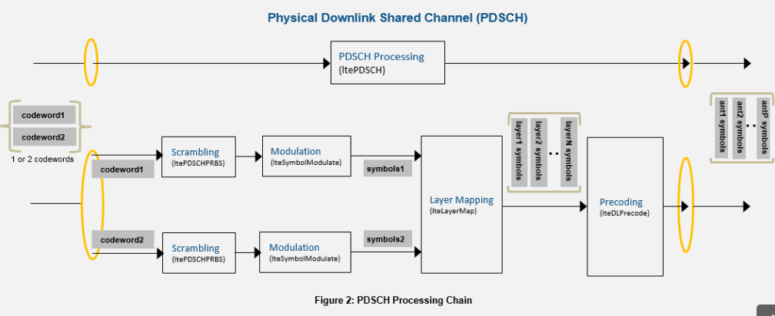

1. Input Data Bits (d): The input data bits represent the information to be transmitted over the PDSCH channel. The data can be any type of digital information, such as voice, video, or text.
2. Channel Coding (CRC + FEC): The input data bits are first channel coded using a cyclic redundancy check (CRC) and a forward error correction (FEC) code. This adds redundant bits to the original data bits to protect against errors that may occur during transmission.
3. Coded Bits (c): The output of the channel coding stage is a set of coded bits that include the original data bits and the added redundant bits.
4. Modulation (QPSK, 16-QAM, 64-QAM): The coded bits are then modulated onto a set of complex symbols using a specific modulation scheme. The modulation scheme used in the 5G system can be QPSK, 16-QAM, or 64-QAM, depending on the data rate and channel conditions.
5. Modulated Symbols (s): The output of the modulation stage is a set of complex symbols that represent the modulated data bits.
6. Resource Mapping (REs): The modulated symbols are then mapped onto a set of resource elements (REs) using a resource mapping algorithm. The resource mapping algorithm determines which symbols are transmitted on which REs, based on the physical layer parameters of the 5G system.
7. Precoding (W): The mapped symbols are then precoded using a specific precoding matrix, W. The precoding matrix is designed to optimize the transmission of data based on the channel conditions and user equipment (UE) capabilities.
8. Precoded Symbols (s'): The output of the precoding stage is a set of precoded symbols that are optimized for transmission over the PDSCH channel.
9. Signal Generation (x): The precoded symbols are combined into a single signal, x, which is then transmitted over the PDSCH channel to the UE.
10. Transmission over PDSCH channel: The PDSCH channel is the physical channel used to transmit the signal from the base station to the UE. The channel characteristics can vary depending on the distance between the base station and the UE, the frequency of the signal, and other environmental factors.

At the UE, the received signal is demodulated, decoded, and processed to recover the original data bits. This involves reversing the steps taken in the transmitter, including channel decoding, demodulation, and resource demapping. The recovered data bits are then used for further processing, such as decoding a voice or video stream.

**CHAPTER-3**

**LITERATURE REVIEW**

**[1] S. Wang, Y. Wang, B. Xu, Y. Li, and W. Xu**:

In this paper, we investigate the capacity performance of an in-band full-duplex (IBFD) amplify-and-forward two-way relay system under the effect of residual loop-back-interference (LBI). In a two-way IBFD relay system, two IBFD nodes exchange data with each other via an IBFD relay. Both two-way relaying and IBFD one-way relaying could double the spectrum efficiency theoretically. However, due to imperfect channel estimation, the performance of two-way relaying is degraded by self-interference at the receiver. Moreover, the performance of the IBFD relaying is deteriorated by LBI between the transmit antenna and the receive antenna of the node. Different from the IBFD one-way relay scenario, the IBFD two-way relay system will suffer from an extra level of LBI at the destination receiver. We derive accurate approximations of the average end-to-end capacities for both the IBFD and half-duplex modes. We evaluate the impact of the LBI and channel estimation errors on system performance. Monte Carlo simulations verify the validity of analytical results. It can be shown that with certain signal-to-noise ratio values and effective interference cancellation techniques, the IBFD transmission is preferable in terms of capacity. The IBFD two-way relaying is an attractive technique for practical applications.

**Summary:**

Analysed about the For both the IBFD and half-duplex modes, we get accurate approximations of average end-to-end capacity. The impact of the LBI and channel estimate errors on system performance is investigated. Monte Carlo simulations are used to test the accuracy of analytical results.

**[2] Z. Zhao, M. Xu, Yong Li, and M. Peng,:** A key problem of content caching networks is that extra radio resource blocks are consumed to push content objects, which leads to a decline of spectrum efficiency. To solve this problem, a non-orthogonal multiple access-based multicast (NOMA-MC) scheme is proposed in this paper, where pushing and multicasting content objects can be accomplished simultaneously, and thus the spectrum efficiency can be improved significantly. To evaluate the performance of the NOMA-MC scheme, an explicit expression of outage probability is derived, which shows that full diversity gains can be achieved in the single-cell scenario. Moreover, the theoretical results can be extended to the multi-cell scenario by establishing a stochastic geometry-based network model, which show that the NOMA-MC scheme can achieve better performance than the conventional orthogonal multiple access-based multicast scheme. Then, the joint design of power allocation and content matching is studied to enlarge the performance gains of the NOMA-MC scheme, and two distributed optimization algorithms are proposed by solving a hospitals/residents matching problem. Finally, simulation results are provided to verify the analytical results, and also demonstrate the performance gains of the NOMA-MC scheme.

**Summary:**

Studied about enlarge the performance gains of the NOMA-MC scheme, and two distributed optimization algorithms are proposed by solving a hospitals/residents matching problem.

**[3]**  [**D.L. Duttweiler,**](https://ieeexplore.ieee.org/author/38289214500) : On typical echo paths, the proportionate normalized least-mean-squares (PNLMS) adaptation algorithm converges significantly faster than the normalized least-mean-squares (NLMS) algorithm generally used in echo cancelers to date. In PNLMS adaptation, the adaptation gain at each tap position varies from position to position and is roughly proportional at each tap position to the absolute value of the current tap weight estimate. The total adaptation gain being distributed over the taps is carefully monitored and controlled so as to hold the adaptation quality (misadjustment noise) constant. PNLMS adaptation only entails a modest increase in computational complexity

**Summary:**

Studied about the adaptation gain in PNLMS adaptation varies from tap position to tap position and is typically proportional to the absolute magnitude of the current tap weight estimate at each tap location.

**[4] Y. Chen,Y. Gu,and A. O. Hero**: We propose a new approach to adaptive system identification when the system model is sparse. The approach applies ℓ1 relaxation, common in compressive sensing, to improve the performance of LMS-type adaptive methods. This results in two new algorithms, the zero-attracting LMS (ZA-LMS) and the reweighted zero-attracting LMS (RZA-LMS). The ZA-LMS is derived via combining a ℓ1 norm penalty on the coefficients into the quadratic LMS cost function, which generates a zero attractor in the LMS iteration. The zero attractor promotes sparsity in taps during the filtering process, and therefore accelerates convergence when identifying sparse systems. We prove that the ZA-LMS can achieve lower mean square error than the standard LMS. To further improve the filtering performance, the RZA-LMS is developed using a reweighted zero attractor. The performance of the RZA-LMS is superior to that of the ZA-LMS numerically. Experiments demonstrate the advantages of the proposed filters in both convergence rate and steady-state behavior under sparsity assumptions on the true coefficient vector. The RZA-LMS is also shown to be robust when the number of non-zero taps increases

**Summary:**

Studied that further improve the filtering performance, the RZA-LMS is developed using a reweighted zero attractor. The performance of the RZA-LMS is superior to that of the ZA-LMS numerically.

**[5]** **Emmanuel J. Candès · Michael B. Wakin :** Stephen P. Boyd: It is now well understood that (1) it is possible to reconstruct sparse signals exactly from what appear to be highly incomplete sets of linear measurements and (2) that this can be done by constrained 1 minimization. In this paper, we study a novel method for sparse signal recovery that in many situations outperforms 1 minimization in the sense that substantially fewer measurements are needed for exact recovery. The algorithm consists of solving a sequence of weighted 1-minimization problems where the weights used for the next iteration are computed from the value of the current solution. We present a series of experiments demonstrating the remarkable performance and broad applicability of this algorithm in the areas of sparse signal recovery, statistical estimation, error correction and image processing. Interestingly, superior gains are also achieved when our method is applied to recover signals with assumed near-sparsity in overcomplete representations—not by reweighting the 1 norm of the coefficient sequence as is common, but by reweighting the 1 norm of the transformed object. An immediate consequence is the possibility of highly efficient data acquisition protocols by improving on a technique known as Compressive Sensing.

**Summary:**

Learned that reweighted 1 minimization outperforms plain 1 minimization in a variety of setups. Therefore, this technique might be of interest to researchers in the field of Compressive Sensing and/or statistical estimation as it might help to improve the quality of reconstructions and/or estimations.

**CHAPTER-4**

**EXISTING METHOD**

Uniform linear array (ULA) is used to simplify the optimization problem and analyze algorithm performance. The signals are narrow band and can be seen as plane wave at receive end. In the model, the arrays are arranged in a line with equal intervals. The angle of incidence θ is the angle between DOA and y axis. The ULA model is shown as Fig.

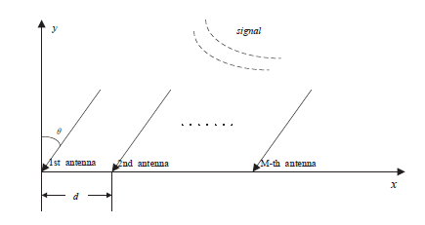

Fig.: ULA

The array consists of M antennas and is used to receive m signals, including SOI, interferences and noise. We assume there are one SOI and  interferences. The incident angles of SOI and interferences  and are expressed as and respectively.

In the ULA, it is assumed that the distance between two adjacent antennas d is  (is the signal wavelength). Then the phase difference between the two adjacent antennas is 

We use the first antenna as a reference. When the incident angle is the corresponding steer vector can be written as  Then the whole steer vector is. In order to construct transmitted signal, we use N denote signal length and x(n) denote the n-th snapshot with n ranges from 1 to N. Then the whole signal x is expressed as below

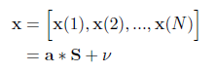

where S is a signal matrix that contains one SOI and m interferences  donates the additive white Gaussian noise(AWGN). It is assumed to be independent from SOI and interferences.

. In this paper, we propose a new algorithms in LCMV. LCMV criterion takes the output power as cost function. It was first proposed by Frost[10]. And it works well in anti-interference. But the convergence rate contradicts with steady state. Many researchers have done a lot to improve the algorithm. However, there still needs more works to push it further. On this point, motivated by [9], we propose a new method on the basis of LCMV. Log-sum penalty is imposed on the cost function. We get the final formulation through mathematical derivation. Compared with traditional singly linearly constrained LMS, simulations are carried out toprove the new method’s superiority. The method outperforms other methods in convergence rate and steady state. Notations: In the following parts, the superscripts and denote the transpose and inverse operators, respectively. denotes the expectation operator and is the component-wise sign function defined as below

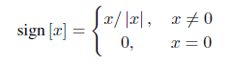

**The proposed Algorithm:**

On the basis of traditional ,singly linearly constrained least mean square (LC-LMS), we introduce a log-sum penalty on the coefficients and add it into the cost function. We derive the iterative formula of filter weights.By simulations in antenna environment with signal of interest, noise and interferences. In this part, we give the specific derivations of the new algorithm. The newly proposed algorithm adds log-sum penalty to the object function on the basis of LC-LMS. The optimization problem is expressed as follows

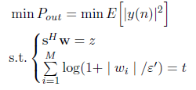

 is the i-th element of the vector w(n).  is a parameter that determines how much each element contributes to the penalty t. Then the Lagrange function can be written as

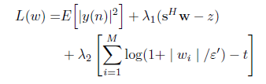

Similarly, through steepest descend method, we get



Where and Pre-multiplying equation (14) with and using the constraint 





In order to reduce the complexity, we make an approximation



The approximation is on the basis of  n is large enough. Now we define and make another approximation



Then pre-multiply equation (14) with and eliminate w(n + 1)

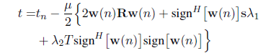

Where   can be denoted as

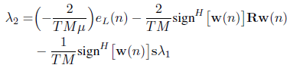

Where ), we can obtain the solutions of Finally, can be rewritten as

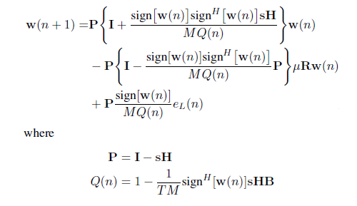

**DISADVANTAGES:**

Complexity: An improved algorithm may be more complex than traditional approaches, requiring more computational resources and potentially increasing the overall system complexity.

Implementation challenges: An improved algorithm may require additional hardware or software resources, and may be more difficult to implement and test in real-world scenarios.

Trade-offs: An improved algorithm may require trade-offs between different performance metrics, such as interference suppression and beamforming accuracy, leading to challenges in optimizing the algorithm for specific use cases.

**CHAPTER-5**

**PROPOSED METHOD**

The Physical Downlink Shared Channel (PDSCH) will use the adaptive beamforming technique with logsum penalty to perform noise reduction among users by using channel encoder codewords that have been updated. The modulator, which may use QAM, QPSK, or another type of modulation, receives the encoded codewords and modulates them before transmitting them at a very fast datarate. After that, the codewords will be assigned to users as resource elements. The allocation of resources to users will subsequently be done using the resource elements. The resources in a memory frame can be accessed via the resource elements. To reduce user interference, the resource elements are precoded.

The precoded codewords can be then transmitted through the physical downlink shared channel (PDSCH). We impose a log-sum penalty on the coefficients and add it to the cost function on the foundation of conventional single linearly constrained least mean square (LC-LMS). We arrive at the filter weights' iterative formula through computer simulations of an antenna environment with an interesting signal, noise, and interferences. In this section, we provide the new algorithm's precise derivations. On the basis of LC-LMS, the recently developed technique penalises the object function with a log-sum. This is how the optimisation problem is stated.



**Analysis of the LC-LMS Algorithm**

To real-time alter the array's coefficients, the LC-LMS algorithm was proposed. Here, we provide a succinct analysis of the algorithm. Let y(n) be the antenna array's observed output.



where w(n) = hw1(n), w2(n), ..., wM(n) iH is the estimated filter coefficient vector, x(n) = hx1(n), x2(n), ..., xM(n) iH is the array input vector. Then the desired output d(n) is expressed as



In the above equation, wo is the optimal coefficient vector and N(n) is the observation AWGN with zero mean and σ2 variance. The LC-LMS filter aims to minimize the output power and maintain the response of the SOI. The optimization problem can be written as,

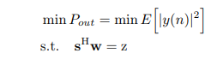

In this part, we give the specific derivations of the new algorithm. The newly proposed algorithm adds log-sum penalty to the object function on the basis of LC-LMS. The optimization problem is expressed as follows,

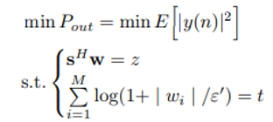

Wi is the i-th element of the vector w(n). ε0 is a parameter that determines how much each element contributes to the penalty t. Then the Lagrange function can be written as,

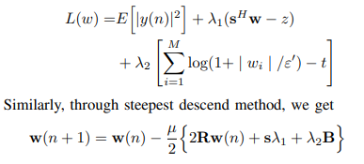

where eL(n) = t − tn. Through (15) and (19), we can obtain the solutions of λ1 and λ2. Finally, can be rewritten as,

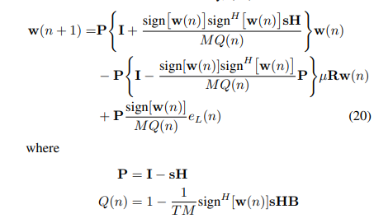

In this section, the performance of the new algorithm is compared with tradition method on Matlab platform. Several experiments have been done to prove the new method’s performance in convergence rate and steady state. Here, we use modulus value of coefficient w(n) to show the convergence rate. Steady state is characterized by MSE. Each experiment is ran many times independently. The specific parameters used in the following experiments are described in below. In the first experiment, we compare the new algorithm with LC-LMS in convergence rate and steady state. First, we use four antennas with one SOI and one interference. The parameters z, t and ε0 are set to be 1.0, 1.0 and 10, respectively. We set the initial value of the weights vector



The optimal coefficient Wo is also provided in the figure. Then the antenna number increases but the transmitted signal remains the same as before. We test how antenna number affect the result. Finally, we set M = 16, increase interference number, keep other parameters unchanged and do similar test.

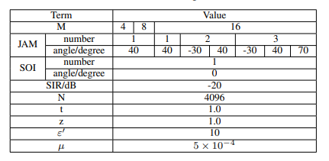

**Fig: Parameter Specification**

Usually, we use normalized F(θ) as a reference,

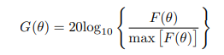

In the equation (21), ε0 and t together make effect on w. ε0 is only a parameter that determines how much each element of w contributes to the penalty and is placed in log function, while t determines the penalty added to the object function. So what makes a difference to the result is the parameter t. Then we give an analysis on t.

In Fig., µ = 5 × 10−4 and ε0 = 10. Other parameters are set unchanged. We can note that when t is too big, the coefficient vector w could not converge to optimal value. However, when t is too small, the result will be sharply jittered around the optimal value. It is vital that we choose proper value for t, or the algorithm will deteriorate seriously. Finally, we take a look at beam pattern of the algorithm. Beam pattern is defined as below,



We provide a brand-new method in this research that is based on the LC-LMS. The object function is given a log-sum penalty, and theoretical analysis is provided step by step until the final formula is derived. After then, experiments are run on the Matlab platform.

The first experiment compares the steady state and convergence rates of the newly suggested method and the LC-LMS.

The outcomes demonstrate the new method's superiority and efficacy. In the second experiment, we examine the variables that could impact how well the method works. We can see that the parameter t's selection affects how well the algorithm performs, so t must be properly selected. In order to conclude, we compare beam patterns. The log-sum LC-LMS performs as well as the LC-LMS, if not better.

The beam pattern is finally been plotted, the codewords after crossing many barriers like channel coding, modulator, resource mapping, precoding, beamforming and signal generation will then be processed and generated the beam pattern in such a way that it almost represented the real pattern of the beam which we have got from the previous implementations. The final signal that are generated in the current stage will be transmitted over the physical downlink shared channel.

**CHAPTER-6**

**ADVANTAGES AND APPLICATIONS**

**Advantages:**

* High Data Rates.
* Resource Sharing
* Adaptive Modulation and Coding
* Efficient Resource Allocation
* Low Latency
* Improved Coverage

**Applications**

1 Applied in 5G system.

2. System Identification.

3.Inverse Modeling.

4.Prediction.

5.Echo Cancellation.

**CHAPTER-7**

**MATLAB**

**7.1 INTRODUCTION TO MATLAB**

**What Is MATLAB?**

MATLAB is an elite dialect for specialized registering. It incorporates calculation, representation, and programming in an easy to-utilize condition wherein issues and preparations are communicated in herbal numerical documentation. Run of the mill utilizes comprise

• Math and calculation

• Algorithm advancement

• Data obtaining

• Modeling, re-enactment, and prototyping

• Data examination, investigation, and representation

• Scientific and designing illustrations

• Application advancement, including graphical UI building

MATLAB is an intuitive framework whose important statistics aspect is an show off that does not require dimensioning. This allows you to tackle several specialized processing issues, particularly those with framework and vector info, in a small quantity of the time it'd take to compose a program in a scalar non intuitive dialect, as an instance, C or FORTRAN.

The call MATLAB stays for grid studies facility. MATLAB changed into first of all composed to present easy access to framework programming created by way of the LINPACK and EISPACK ventures. Today, MATLAB motors fuse the LAPACK and BLAS libraries, inserting the cutting side in programming for network calculation.

MATLAB has advanced over a time of years with contribution from several customers. In university situations, it's far the usual academic apparatus for early on and propelled guides in mathematics, designing, and science. In enterprise, MATLAB is the tool of choice for excessive-profitability studies, advancement, and exam.

MATLAB highlights a collection of more utility-specific arrangements known as tool booths. Important to most clients of MATLAB, device kits permit you to learnandapply particular innovation. Tool compartments are exhaustive accumulations of MATLAB capacities (M-records) that reach out the MATLAB condition to take care of precise training of problems. Territories in which tool stash are reachable include flag coping with, manipulate frameworks, neural structures, fluffy reason, wavelets, pastime, and severa others.

**The MATLAB System:**

The MATLAB system consists of five main parts.

**Development Environment:**

 This is the set of tools and centres that help you operate MATLAB features and files. Many of that gear are graphical person interfaces. It includes the MATLAB desktop and Command Window, a command history, an editor and debugger, and browsers for viewing assist, the workspace, files, and the hunt direction.

**The MATLAB Mathematical Function:**

This is a great collection of computational algorithms ranging from standard capabilities like sum, sine, cosine, and complex arithmetic, to extra sophisticated features like matrix inverse, matrix eigen values, Bessel functions, and speedy Fourier transforms.

**The MATLAB Language:**

This is a high-level matrix/array language with control flow statements, functions, data structures, input/output, and object-oriented programming features. It allows both "programming in the small" to rapidly create quick and dirty throw-away programs, and "programming in the large" to create complete large and complex application programs.

**Graphics:**

MATLAB has considerable centres for displaying vectors and matrices as graphs, as well as annotating and printing those graphs. It consists of high-stage functions for 2-dimensional and 3-dimensional records visualization, photograph processing, animation, and presentation graphics. It also consists of low-stage capabilities that will let you absolutely customise the appearance of graphics as well as to construct complete graphical person interfaces for your MATLAB programs.

**The MATLAB Application Program Interface (API):**

This is a library that allows you to put in writing C and Fortran applications that have interaction with MATLAB. It consists of facilities for calling workouts from MATLAB (dynamic linking), calling MATLAB as a computational engine, and for studying and writing MAT-documents.

**7.2 MATLAB WORKING ENVIRONMENT:**

## MATLAB DESKTOP:

Matlab Desktop is the principle Matlab application window. The desktop consists of five sub windows, the summon window, the workspace program, the existing catalog window, the order records window, and at the least one figure home windows, which can be proven simply while the consumer suggests a sensible.

The order window is the area the customer sorts MATLAB orders and expressions at the initiate (>>) and wherein the yield of these fees is shown. MATLAB characterizes the workspace because the association of factors that the customer makes in a work session. The workspace software demonstrates these elements and some statistics approximately them. Double tapping on a variable within the workspace application dispatches the Array Editor, which may be applied to get data and salary instances modify sure homes of the variable.

The present Directory tab over the workspace tab demonstrates the substance of the existing registry, whose way is seemed within the present index window. 1For case, within the windows running framework the manner may be as consistent with the subsequent: C:MATLABWork, demonstrating that registry "paintings" is a subdirectory of the primary catalog "MATLAB", which is delivered in pressure C. Tapping on the bolt inside the present index window demonstrates a rundown of as of past due utilized approaches. Tapping at the seize to one aspect of the window enables the client to exchange the existing catalog.

MATLAB utilizes an inquiry way to discover M-data and different MATLAB related documents, which might be sort out in catalogs within the PC file framework. Any file keep strolling in MATLAB must dwell inside the ebb and go with the flow registry or in an index that is on are trying to find manner. Of direction, the statistics supplied with MATLAB and math works device kits are included into the inquiry way. The least stressful method to look which indexes are at the inquiry manner. The handiest method to peer which catalogs are soon the quest way, or to encompass or regulate an inquiry manner, is to pick set manner from the File menu the computer, and after that utilization the set way exchange container. It is exquisite exercise to add any typically utilized catalogs to the pursuit way to hold a strategic distance from again and again having the exchange the existing index.

The Command History Window contains a record of the orders a client has entered in the charge window, including both present and past MATLAB sessions. Already entered MATLAB orders can be chosen and re-executed from the charge history window by right

tapping on a summon or arrangement of orders. This activity dispatches a menu from which to choose different choices notwithstanding executing the orders. This is helpful to choose different choices notwithstanding executing the summons. This is a valuable component while trying different things with different orders in a work session

**Using the MATLAB Editor to create M-Files:**

The MATLAB manager is both a word processor unique for making M-statistics and a graphical MATLAB debugger. The proofreader can display up in a window without everybody else, or it could be a sub window in the laptop. M-facts are intended by means of the expansion .M, as in pixelup.M. The MATLAB editorial manager window has various draw down menus for errands, for instance, sparing, seeing, and troubleshooting documents. Since it plays out a few basic checks and furthermore utilizes shading to separate between exclusive additives of code, this content device is suggested as the equipment of selection for composing and changing M-capacities. To open the proofreader, sort regulate at the incite opens the M-report filename.M in a supervisor window, organized for altering. As referred to before, the record has to be inside the momentum catalog, or in an index within the pursuit manner.

**Getting Help:**

The important technique to get help on line is to utilize the MATLAB assist application, opened as a exclusive window both via tapping at the query mark image at the computing device toolbar, or by using writing help program on the provoke within the order window. The help Browser is an internet application coordinated into the MATLAB computing device that shows a Hypertext Markup Language (HTML) statistics. The Help Browser contains of two sheets, the assistance pilot sheet, used to find out data, and the show sheet, used to look the statistics. Clear as crystal tabs aside from pilot sheet are applied to play out a pursuit. Second, within the motion pictures taken via transferring camera setup, the state of affairs becomes extra complex because the heritage may additionally exchange by using shifting shot, we cannot tune item motion exactly inside the sum of distinction map. Therefore, in this situation, the purpose is executed through reusing the previous seam and applying it to the cutting-edge body. In order to discover the seams, we use the preceding seam from previous body to look the modern-day seam in contemporary frame. our method is using a seam computed in frame1 (in crimson) to go looking a comparable seam in frame2. For the pixels close by the area of previous seam, we decide how a lot the selected pixel might vary from the pixel of preceding seam. We use difference of the 2 pixels as the degree of temporal coherence. If the distinction value of first seam pixel is over the threshold, we can keep to go looking the next seam pixel on three feasible pixels (in yellow, blue and brown) in subsequent row, until we discover 5 consecutive pixels that also exceed the threshold.

When we can't search the matching seam, we recalculate the energy for a new seam. We assume a seam 𝑆l-1 has been calculated inside the previous body, and a seam must be calculated for the contemporary frame. For preserving the temporal coherence, we want to make a new seam close to the previous seam with the identical index. We use the distinction among preceding seam and all pixels at the current body as the measure

Thus we upload temporal coherence price Tc(i,j) to the strength map earlier than calculating a seam 𝑆L. The price Tc is zero while the body pixels have the equal fee as previous seam pixels. Using our temporal coherence price, we will calculate the seam which has least electricity and is more close to the preceding seam in previous frame. Consequently, we will decrease the jittery artifacts inside the films.

**COMMUNICATION:**

Communications System Toolbox™ offers algorithms and gear for the layout, simulation, and analysis of communications systems. These capabilities are furnished as MATLAB ® features, MATLAB System gadgets™, and Simulink ® blocks. The machine toolbox includes algorithms for source coding, channel coding, interleaving, modulation, equalization, synchronization, and channel modeling. Tools are supplied for bit blunders charge evaluation, producing eye and constellation diagrams, and visualizing channel characteristics. The machine toolbox additionally provides adaptive algorithms that allow you to version dynamic communications structures that use OFDM, OFDMA, and MIMO techniques. Algorithms support fixed-point facts arithmetic and C or HDL code era.

**Key Features**

▪ Algorithms for designing the physical layer of communications systems, which includes supply coding, channel coding, interleaving, modulation, channel fashions, MIMO, equalization, and synchronization

▪ GPU-enabled System objects for computationally intensive algorithms together with Turbo, LDPC, and Viterbi decoders

▪ Interactive visualization equipment, consisting of eye diagrams, constellations, and channel scattering capabilities

▪ Graphical tool for evaluating the simulated bit mistakes rate of a machine with analytical outcomes

▪ Channel models, consisting of AWGN, Multipath Rayleigh Fading, Rician Fading, MIMO Multipath Fading, and

LTE MIMO Multipath Fading

▪ Basic RF impairments, along with nonlinearity, section noise, thermal noise, and section and frequency offsets

▪ Algorithms available as MATLAB features, MATLAB System objects, and Simulink blocks

▪ Support for fixed-point modeling and C and HDL code technology

**System Design, Characterization, and Visualization:**

The layout and simulation of a communications gadget requires analyzing its reaction to the noise and interference inherent in real-world environments, reading its behavior the usage of graphical and quantitative manner, and determining whether the resulting overall performance meets requirements of acceptability. Communications System Toolbox implements a selection of obligations for communications machine layout and simulation. Many of the functions, System objects™, and blocks inside the device toolbox perform computations associated with a specific thing of a communications gadget, consisting of a demodulator or equalizer. Other talents are designed for visualization or evaluation.

**System Characterization**

The system toolbox offers several standard methods for quantitatively characterizing system performance:

▪ Bit error rate (BER) computations

▪ Adjacent channel power ratio (ACPR) measurements

▪ Error vector magnitude (EVM) measurements

▪ Modulation error ratio (MER) measurements

Because BER computations are fundamental to the characterization of any communications system, the system toolbox provides the following tools and capabilities for configuring BER test scenarios and accelerating BER simulations:

**BER tool**— A graphical user interface that enables you to analyze BER performance of communications systems. You can analyze performance via a simulation-based, semi analytic, or theoretical approach.

**Error Rate Test Console** — A MATLAB object that runs simulations for communications systems to measure error rate performance. It supports user-specified test points and generation of parametric performance plots and surfaces. Accelerated performance can be realized when running on a multi core computing platform.

**Multi core and GPU acceleration** — A capability provided by Parallel Computing Toolbox™ that enables you to accelerate simulation performance using multi core and GPU hardware within your computer.

**Distributed computing and cloud computing support** — Capabilities provided by Parallel Computing Toolbox and MATLAB Distributed Computing Server™ that enable you to leverage the computing power of your server farms and the Amazon EC2 Web service. Performance Visualization. The system toolbox provides the following capabilities for visualizing system performance:

**Channel visualization tool** — For visualizing the characteristics of a fading channel

**Eye diagrams and signal constellation scatter plots** — for a qualitative, visual understanding of system behavior that enables you to make initial design decisions

**Signal trajectory plots** — for a continuous picture of the signal’s trajectory between decision points

**BER plots** — for visualizing quantitative BER performance of a design candidate, parameterized by metrics such as SNR and fixed-point word size

**Analog and Digital Modulation**

Analog and digital modulation strategies encode the facts circulation into a sign this is appropriate for transmission. Communications System Toolbox presents some of modulation and corresponding demodulation abilities. These talents are available as MATLAB features and gadgets, MATLAB System Modulation sorts provided by the toolbox are:

**Analog,** including AM, FM, PM, SSB, and DSBSC

**Digital,** including FSK, PSK, BPSK, DPSK, OQPSK, MSK, PAM, QAM, and TCM

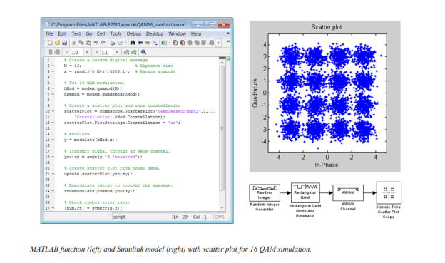

**Source and Channel Coding**

Communications System Toolbox affords source and channel coding talents that can help you develop and compare communications architectures fast, enabling you to discover what-if eventualities and avoid the need to create coding competencies from scratch.

**Source Coding**

Source coding, also referred to as quantization or signal formatting, is a manner of processing facts a good way to lessen redundancy or prepare it for later processing. The system toolbox offers a diffusion of styles of algorithms for imposing source coding and interpreting, inclusive of:

▪ Quantizing

▪ Companding (*µ*-law and A-law)

▪ Differential pulse code modulation (DPCM)

▪ Huffman coding

▪ Arithmetic coding

**Channel Coding**

▪ orthogonal area-time block code (OSTBC) (encoder and decoder for MIMO channels)

▪ Turbo encoder and decoder examples

The gadget toolbox offers application functions for developing your personal channel coding. You can create generator polynomials and coefficients and syndrome deciphering tables, in addition to product parity-take a look at and generator matrices.

The system toolbox additionally presents block and convolutional interleaving and deinters leaving functions to reduce facts errors as a result of burst mistakes in a conversation machine:

**Block,** including General block interleaver, algebraic interleaver, helical scan interleaver, matrix interleaver, and random interleaver.

**Convolutional,** including General multiplexed interleaver, convolutional interleaver, and helical interleaver

**Channel Modeling and RF Impairments**

Channel Modeling

Communications System Toolbox provides algorithms and tools for modeling noise, fading, interference, and different distortions which might be commonly found in communications channels. The system toolbox supports the subsequent styles of channels:

▪ Additive white Gaussian noise (AWGN)

▪ Multiple-enter multiple-output (MIMO) fading

▪ Single-enter single-output (SISO), Rayleigh, and Rician fading

▪ Binary symmetric

A MATLAB channel object provides a concise, configurable implementation of channel models, enabling you to

specify parameters such as:

▪ Path delays

▪ Average path gains

▪ Maximum Doppler shifts

▪ K-Factor for Rician fading channels

▪ Doppler spectrum parameters

For MIMO systems, the MATLAB MIMO channel object expands these parameters to also include:

▪ Number of transmit antennas (up to 8)

▪ Number of receive antennas (up to 8)

▪ Transmit correlation matrix

▪ Receive correlation matrix

To combat the effects noise and channel corruption, the system toolbox provides block and convolutional coding and decoding techniques to implement error detection and correction. For simple error detection with no inherent correction, a cyclic redundancy check capability is also available. Channel coding capabilities provided by the system toolbox include:

▪ BCH encoder and decoder

▪ Reed-Solomon encoder and decoder

▪ LDPC encoder and decoder

▪ Convolutional encoder and Viterbi decoder

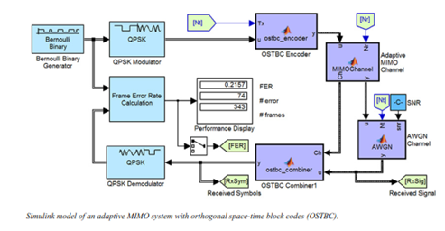

**RF Impairments**

To model the effects of a non-ideal RF front end, you can introduce the following impairments into your communications system, enabling you to explore and characterize performance with real-world effects:

▪ Memory less nonlinearity

▪ Phase and frequency offset

▪ Phase noise

▪ Thermal noise

You can include more complex RF impairments and RF circuit models in your design using SimRF™.

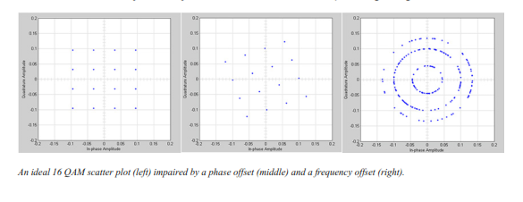

**Equalization and Synchronization**

Communications System Toolbox lets you discover equalization and synchronization strategies. These techniques are usually adaptive in nature and tough to design and symbolize. The machine toolbox affords algorithms and tools that will let you swiftly select the proper approach on your communications machine. Equalization To compare one-of-a-kind techniques to equalization, the device toolbox offers you with adaptive algorithms which include:

▪ LMS

▪ Normalized LMS

▪ Variable step LMS

▪ Signed LMS

▪ MLSE (Viterbi)

▪ RLS

▪ CMA

These adaptive equalizers are available as nonlinear decision feedback equalizer (DFE) implementations and as

Linear (symbol or fractionally spaced) equalizer implementations.

**Synchronization**

The device toolbox provides algorithms for each service segment synchronization and timing phase synchronization. For timing section synchronization, the machine toolbox presents a MATLAB Timing Phase Synchronizer object that offers the following implementation techniques:

▪ Early-late gate timing method

▪ Gardner’s method

▪ Fourth-order nonlinearity method

**Stream Processing in MATLAB and Simulink**

Most verbal exchange structures cope with streaming and frame-primarily based statistics using a aggregate of temporal processing and simultaneous multi frequency and multichannel processing. This form of streaming multidimensional processing can be visible in superior communication architectures consisting of OFDM and MIMO. Communications System Toolbox enables the simulation of advanced communications structures via helping move processing and frame-based simulation in MATLAB and Simulink. In MATLAB, circulate processing is enabled by way of System items™, which use MATLAB objects to symbolize time-based and facts-driven algorithms, sources, and sinks. System objects implicitly manipulate many information of flow processing, including information indexing, buffering, and management of set of rules state. You can mix System gadgets with fashionable MATLAB functions and operators. Most System items have a corresponding Simulink block with the identical abilities. Simulink handles circulation processing implicitly with the aid of coping with the float of information thru the blocks that make up a Simulink model. Simulink is an interactive graphical environment for modeling and simulating dynamic systems that uses hierarchical diagrams to symbolize a machine version. It includes a library of widespread-reason, predefined blocks to represent algorithms, resources, sinks, and device hierarchy.

**Implementing a Communications System**

Fixed-Point Modeling Many communications systems use hardware that requires a fixed-point representation of your design.

Communications System Toolbox supports fixed-point modeling in all relevant blocks and System objects™ with tools that help you configure fixed-point attributes.

Fixed-point support in the system toolbox includes:

▪ Word sizes from 1 to 128 bits

▪ Arbitrary binary-point placement

▪ Overflow handling methods (wrap or saturation)

▪ Rounding methods: ceiling, convergent, floor, nearest, round, simplest, and zero

Fixed-Point Tool in Simulink Fixed Point™ facilitates the conversion of floating-point data types to fixed point. For configuration of fixed-point properties, the tool tracks overflows and maxima and minima.

**Code Generation**

Once you've got advanced your set of rules or communications device, you can robotically generate C code from it for verification, rapid prototyping, and implementation. Most System gadgets, functions, and blocks in Communications System Toolbox can generate ANSI/ISO C code the use of MATLAB Coder™, Simulink Coder™, or Embedded Coder™. A subset of System gadgets and Simulink blocks also can generate HDL code. To leverage present highbrow belongings, you can choose optimizations for specific processor architectures and integrate legacy C code with the generated code.

You can also generate C code for both floating-point and fixed-point data types.

DSP Proto typing DSPs are used in communication system implementation for verification, rapid prototyping, or final hardware implementation. Using the processor-in-the-loop (PIL) simulation capability found in Embedded Coder, you can verify generated source code and compiled code by running your algorithm’s implementation code on a target processor. FPGA Prototyping

FPGAs are used in communication systems for implementing high-speed signal processing algorithms. Using the FPGA-in-the-loop (FIL) capability found in HDL Verifier™, you can test RTL code in real hardware for any existing HDL code, either manually written or automatically generated HDL code.

**CHAPTER -8**

**HARDWARE & SOFTWARE REQUIREMENTS:**

**Software:**

• Matlab R2018a.

**Hardware:**

**Operating Systems:**

• Windows 10

• Windows 7 Service Pack 1

• Windows Server 2019

• Windows Server 2016

**Processors:**

Minimum: Any Intel or AMD x86-64 processor

Recommended: Any Intel or AMD x86-64 processor with four logical cores and AVX2 instruction set support

**Disk:**

Minimum: 2.9 GB of HDD space for MATLAB only, 5-8 GB for a typical installation

Recommended: An SSD is recommended a full installation of all Math Works products may take up to 29 GB of disk space

**RAM:**

Minimum: 4 GB

Recommended: 8

**CHAPTER-9**

**RESULTS**

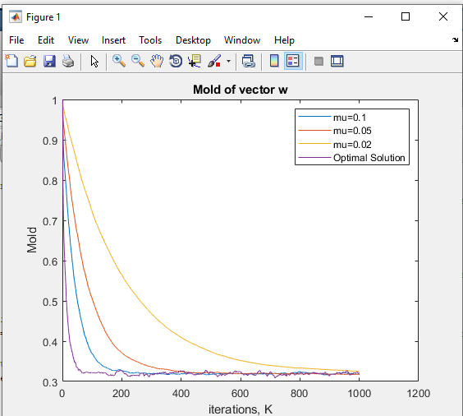

Figure :Convergence Rate with different mu

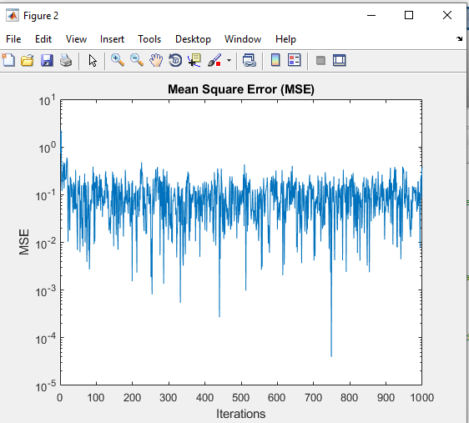

**Figure :Mean Square Error with M=4**

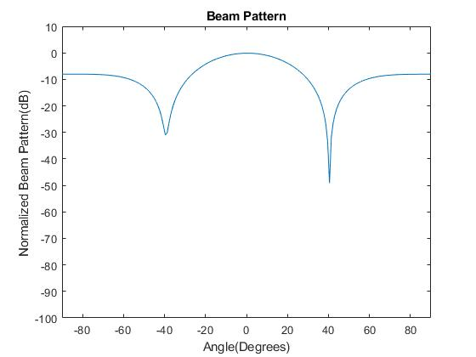

**Figure :Beam pattern**

**CHAPTER-10**

**CONCLUSION**

We proposed a new algorithm based on the LC-LMS. We add log-sum penalty to the object function and give theoretical analysis step by step until derive the final formula. Then experiments are carried out on Matlab platform. The first experiment aims to compare the newly proposed algorithm with LC LMS in convergence rate and steady state. The results prove the effectiveness and superiority of the new method. In the second experiment, we analyze the factors that may affect the performance of the method. We can see that the choice of parameter t determines the algorithm performance, so t should be set properly. Finally, we make a comparison in beam pattern. The log-sum LC-LMS has the same performance as LC-LMS, or better. The above implementation has been implemented in the PDSCH where signal is generated before transferred through PDSCH. The signal that is transferred will be formed for transmission will be formed and verified through analysing its beam pattern.

**CHAPTER-12**

**REFERENCES**

[1] S. Wang, Y. Wang, B. Xu, Y. Li, and W. Xu, “Capacity of two-way in-band full-duplex relaying with imperfect channel state information,” IEICE Trans. Commun., vol. E101-B, no. 4, pp. 1108–1115, Apr. 2018.

[2] S. Wang, D. D Wang, C. Li, and W. B Xu. “Full Duplex AF and DF Relaying Under Channel Estimation Errors for V2V Communications,” IEEE Access. vol. 6, pp. 65321-65332, Nov., 2018.

[3] Z. Zhao, S. Bu, T. Zhao, Z. Yin, M. Peng, Z. Ding, and Tony Q. S. Quek, “On the design of computation offloading in fog radio access networks,” to appear in IEEE Trans. on Veh. Technol., [Online] Availiable:https://ieeexplore.ieee.org/document/8730522.

[4] Z. Zhao, M. Xu, Yong Li, and M. Peng, “A non-orthogonal multiple access-based multicast scheme in wireless content caching networks,” IEEE J. Sel. Areas Commun., vol. 35, no. 12, pp. 2723–2735, July 2017.

[5] B. Widrow and S. D. Stearns, Adaptive Signal Processing, New Jersey: Prentice Hall, 1985.

[6] D.L. Duttweiler, “Proportionate normalized least-meansquares adaptation in echo cancelers,” IEEE Trans. Speech Audio Process., vol. 8, pp. 508C- 518, 2000.

[7] W.Y. Chen, R.A. Haddad, “A variable step size LMS algorithm,” Proceedings of the 33rd Midwest Symposium on Circuits and Systems, 1990, pp. 636–640.

[8] Zhang Yuan, Xi Songtao, “Application of New LMS Adaptive Filtering Algorithm with Variable Step Size in Adaptive Echo Cacellation”. 17th IEEE International Conference on Communication Technology, 2017

[9] Y. Chen,Y. Gu,and A. O. Hero, “Sparse lms for system identification,” in Proceeding of the IEEE International Conference on Acoustics, Speech and Signal Processing, 2009, pp. 3125–3128.

[10] O. L. Frost, “An algorithm for linearly constrained adaptive array processing,” Proceedings of the IEEE, vol. 60, no. 8, pp. 926-C935, 1972.

[11] E. J. Cand‘ es, M. Wakin, and S. Boyd, “Enhancing sparsity by reweighted l1 minimization,” To appear in J. Fourier Anal. Appl.

[12] M. Godavarti and A. O. Hero, “Partial update LMS algorithms,” IEEE Trans. Signal Process., vol. 53, pp. 2382-C2399, 2005.

[13] P.S.R.Diniz, Adaptive Filtering : Algorithmand Practical Implementation,3rd ed. Spring, Oct,2010.